1. **Home page and chronicles design change**
2. **13. In about us Page remove video both and Type of challenges like this**

**Type of challenges**

|  |  |
| --- | --- |
| FUNDING In our funding program, we provide our customer demand with a suitable loan amount to the solutions. | NON FUNDING In our non-funding program we provide only solutions to the seeker to grow your business. |

**4. In Challenges – solver can view the image and videos view from challenges**

**5. Summit solution button on center and size (big) Instructions of summit solution**

**6. Add category to chronicles examples**

1. Title 2.Tags

3. Category (Top down menu, electricity, productivity, etc) 4.

4. Content change into Description

5. Technical info

6. Benefits

7. Industry (top down menu textile, plastic, wood, cables, paper, automation, electronic, glass, steel, other) in this solver can select all and multiple or single Industry

8. Contact link /button (image below)

And points show in bold front (like this)

**Add filter in chronicles page of industry** (top down menu textile, plastic, wood, cables, paper, automation, electronic, glass, steel, other)

On left side of chronicles



**Remove this from chronicles**



**4. photo/videos in chronicles – in chronicles post user can post video or image (one of them on top of chronicles)**

**5. In the end of every chronicle contact button solver will   in every chronicle like this. End of chronicle**



**6. Chronicle design **

3 in one row

**7. profile update and other submission like (solution in challenges, post chronicle and all seen) show your successful and not successful (like this)**



**8. Instructions of post chronicle will show to solver.**

**10. Button on server page problem solving, funding, chronicle button on these**

** Into **

**11. Contact us page form**



**Change into**

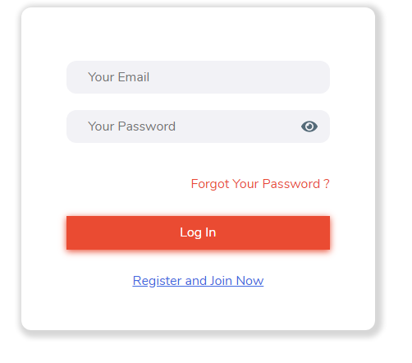

**Name**

**Email**

**Contact no.**

**Message**

**12.**



**Automation Quality control**

**13. service page will change into (**<https://triiii-final.netlify.app/services.html>)